Project Development Phase
Model Performance Test
Date | 01 September 2026
Team ID | Individual Project
Project Name | Software Installation Request Automation in ServiceNow Using Service Catalog and Workflows
Maximum Marks | 10 Marks

Model Performance Testing:
S.No. | Parameter | Values / Screenshot
1 | Metrics | Software Installation Request automation validation:  • Service Catalog request submission  • Workflow approval and task creation  • Request / Requested Item / Catalog Task record validation  • Business Rule incident creation for license shortage  • Update Set transfer validation  Screenshot:  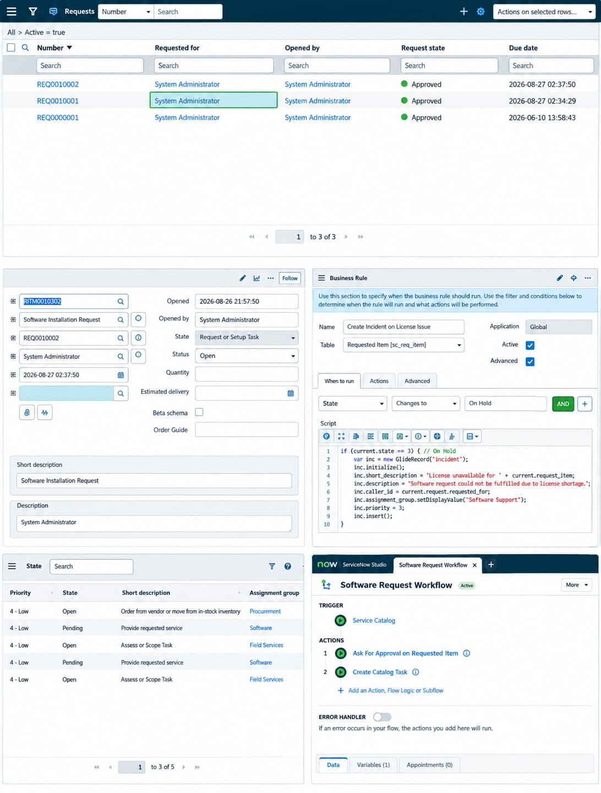
2 | Tune the Model | Configuration activities:  • Catalog item and variables configured  • Workflow activities connected and published  • Workflow attached to the catalog item  • Business Rule configured for On Hold / license shortage  • Update Set completed, exported, retrieved, previewed, and committed  Screenshot:  